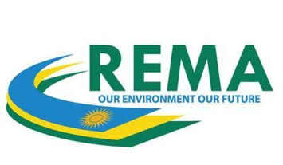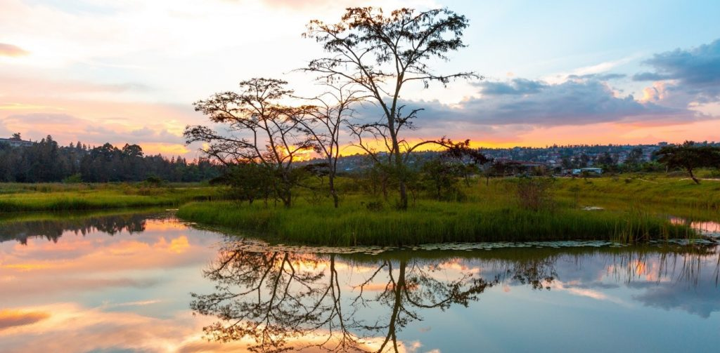



**Thursday, 10 November 2022**

**13:30 – 14:30**

A rapid urbanization comes with enormous challenges for city planners and managers. They have to ensure that cities today can deliver not only basic services but that these cities are safe, resilient and environmentally friendly.

Urban wetlands can play a key role but are nevertheless seriously threatened by human activities. One of the underlying causes of wetland degradation is lack of knowledge and skills on how they can be used to manage pollution and flood risks and lack of their value to biodiversity conservation.

This side event aims at showcasing innovative approaches for urban wetlands conservation in a green development perspective, focusing on the experience of the Nyandungu Urban Wetland Eco-tourism Park in Kigali, Rwanda.

***Moderator***

**Ingvild Solvang**, Deputy Director and Head of Climate Action and Inclusive Development Global Practice at the **Global Green Growth Institute** (GGGI)

***Opening remarks***

**Alessandro Modiano**, Italy Special Envoy for Climate Change and Director General at the **Italian Ministry of Ecological Transition** (IMET)

**Faustin Munyazikwiye**, Deputy Director General at the **Rwanda Environment Management Authority** (REMA)

***Panellists***

**Roberta Ronzitti,** International Cooperation Division Director at the **Italian Ministry of Ecological Transition** (IMET)

**Mallé Fofana**, Director and Head of Programs Africa & Europe at the **Global Green Growth Institute** (GGGI)

**Teddy Mugabo**, CEO of the **Rwanda National Fund for Environment** (FONERWA)

**Faustin Munyazikwiye**, Deputy Director General at the **Rwanda Environment Management Authority** (REMA)

***Closing remarks***

**Roberta Ronzitti,** International Cooperation Division Director at the **Italian Ministry of Ecological Transition** (IMET)

**COP 27 SIDE EVENT**

**INNOVATIVE APPROACHES TO RESTORATION AND CONSERVATION OF URBAN WETLANDS**

**The case study of the project “*Sustainable Urban Wetlands Development in Kigali City*”**



**Blue Zone, Area C,**

**Delegations offices 2, ITALY**